

|  |
| --- |
| The Battle of Neighborhoods 2019 |
|  |
| April 3  ABDIS’ ASSIGNMENT  Authored by: Mohyeddin Abdi |

Contents

Capstone Project – The Battle of Neighborhoods 3

Introduction 4

Background 4

Data Description 4

Methodology 5

Create Data Frame 5

Visualizing the data 6

Finding Venues 8

Visualizing the Venues 9

Examine the Clusters 11

Result 12

Discussion 16

Conclusion 16

References 16

# Capstone Project – The Battle of Neighborhoods

|  |
| --- |
| **Introduction**Background There are many cities with many differences. This report will find the similarity and dissimilarity of Toronto, Sydney and Tokyo. The audience of this report are tourists and who interested in different cultural diversity study.   1. Toronto is the provincial capital of Ontario in Canada with population of 2,731,571 in 2016(Toronto – Wikipedia 2019). 2. Sydney is the stat capital of New South Wales with estimated population of 5,230,330 in 2017 (Sydney – Wikipedia 2019) 3. Tokyo is the capital of Japan, its population exceeding 13.8 million (Tokyo – Wikipedia 2019).     All these cities are the financial capital of their respected countries. It will be predicted that Toronto and Sydney have close similarity and also dissimilarity between these cities and Tokyo, but see what our exploring, segmenting and clustering of their neighborhoods have to say. Data Description  * Australian data is from Corra site (<http://www.corra.com.au/australian-postcode-location-data/>) * Tokyo’s data created base on neighborhoods list in this site (<https://www.japan-talk.com/jt/new/tokyo-neighborhoods>) and search for the latitude and longitude added to the list as csv file. * Toronto data is from the week 3 analysis but its borough column removed for easy comparison. * The Find Latitude and Longitude site (<https://www.findlatitudeandlongitude.com/>) has used to get the boundary of these cities and make sure we are not out of metropolitan area. * Foursquare API service has used to get the required data for the report. |

## **Methodology**

### Create Data Frame

The report has three source of data, Sydney data filtered from Australian postcode and location csv. This data has been changed in the way to be the same with other cities.

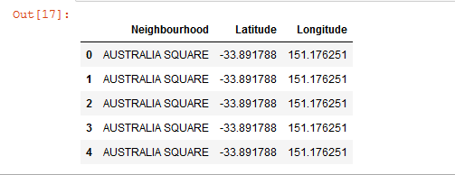

Tokyo data has been created by getting its neighborhood list and search for their latitude and longitude of these neighborhoods, and save it as csv file than uploaded to my Jupyter notebook server, after data frame created.

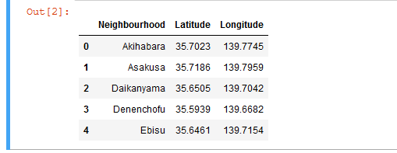

The same with Toronto data that I used the early part of this course assignment.

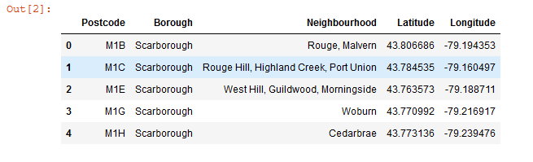

### Visualizing the data

For the first part of all these data frame, it used the Python Folium library for visualization. So, their neighborhood details and location are clear and explorable by zooming in and out. Every dot in the map is representing a neighborhood, by clicking on it you can see the details of that point.

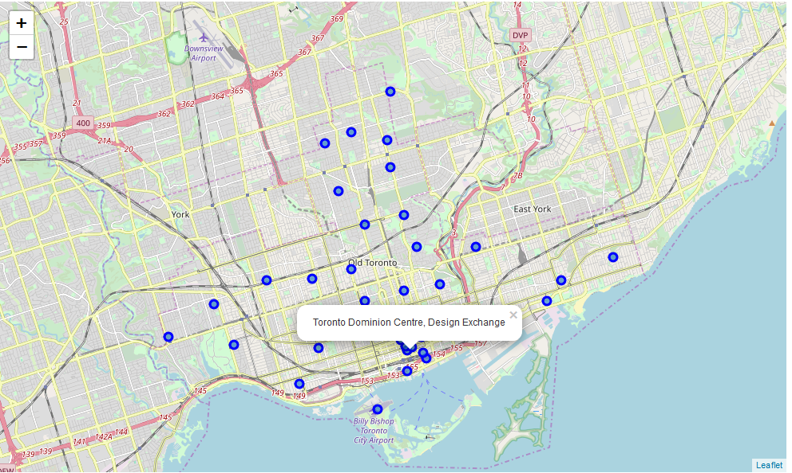

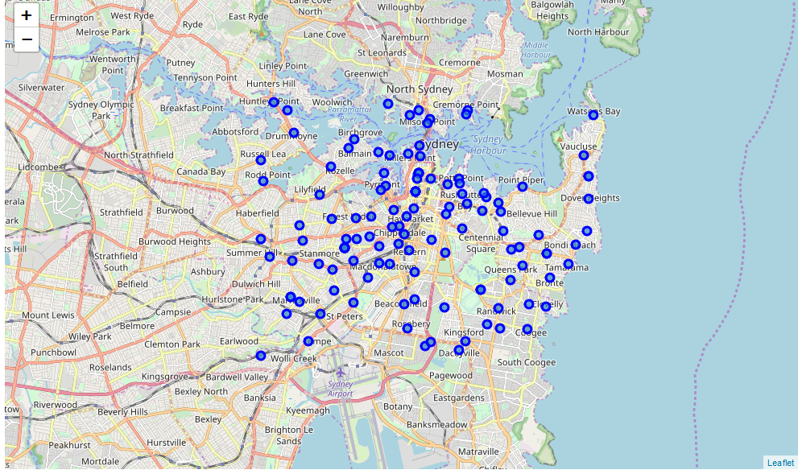

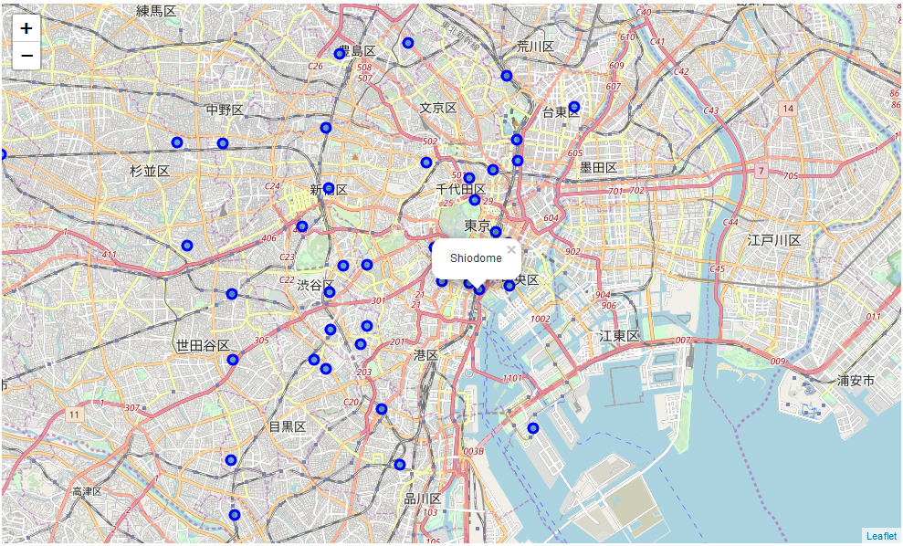

### Finding Venues

The next steps, utilizing Foursquare API to explore and finding the venues in these cities. I used the same limit (100) and radius (500) for all three cities and I got the list of venues as shown below. This list is the first five venues’ list.

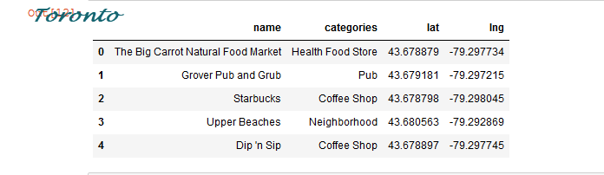

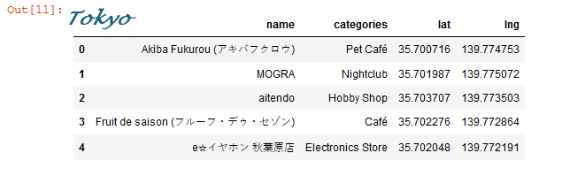

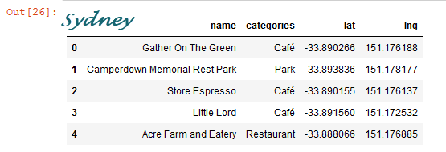

The total venues that the Foursquare found in these cities are:

* Sydney 4533 in 128 neighborhoods, it has 243 unique categories
* Toronto 1699 in 103 neighborhoods, it has 237 unique categories
* Tokyo 3321 in 43 neighborhoods, it has 261 unique categories

### Visualizing the Venues

The next step is to creating new data frame with 10 most common venues after I used K-Means for clustering the new data frame into 5 clusters.

I use the folium again to visualizing these clusters and see the biggest cluster in every city:

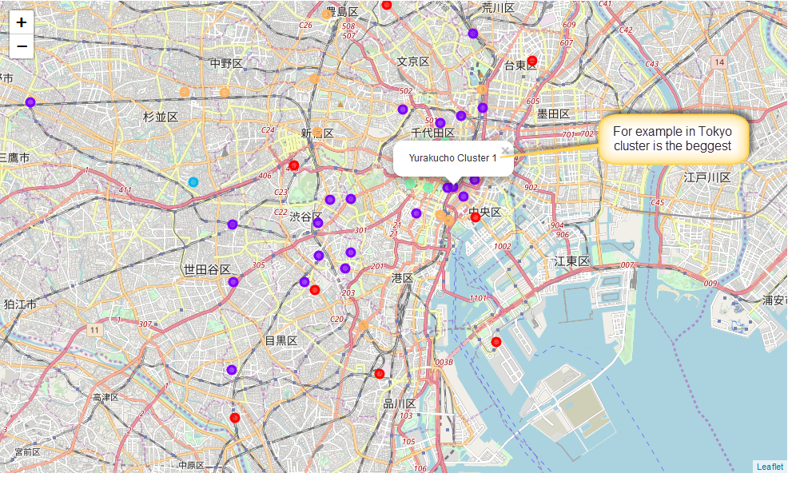

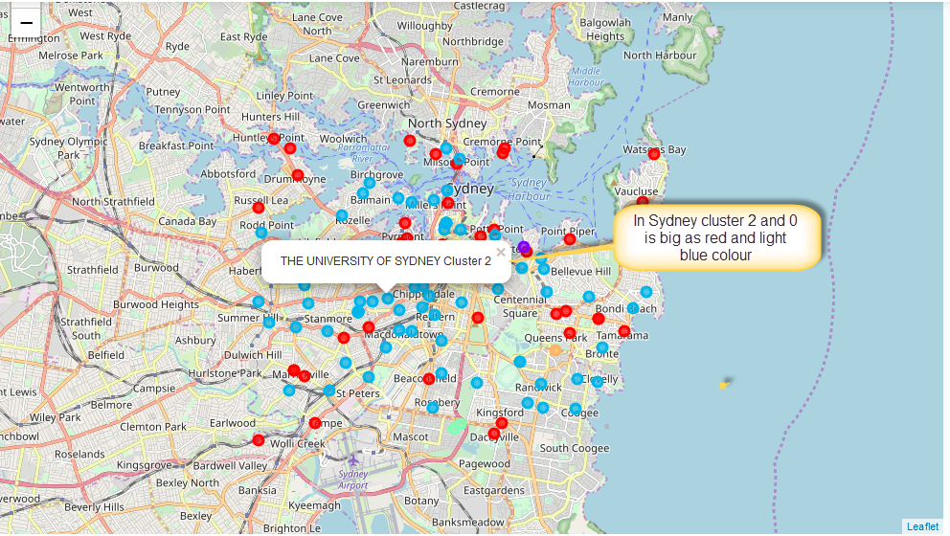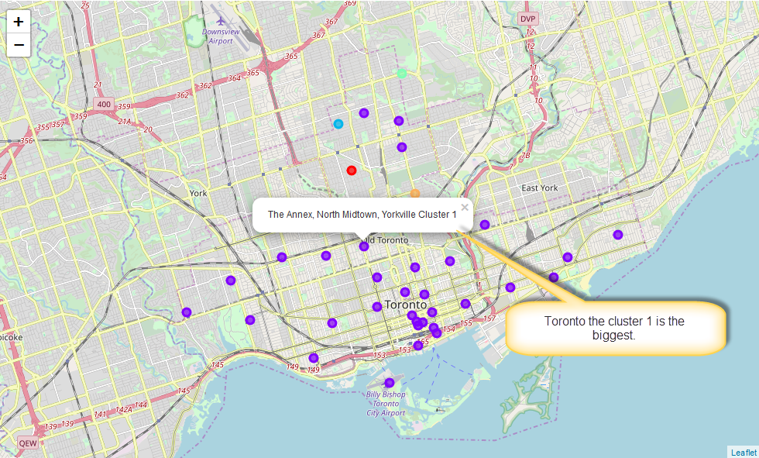

### Examine the Clusters

The final step in my data analysis I examine the clusters, mostly check the bigger cluster.

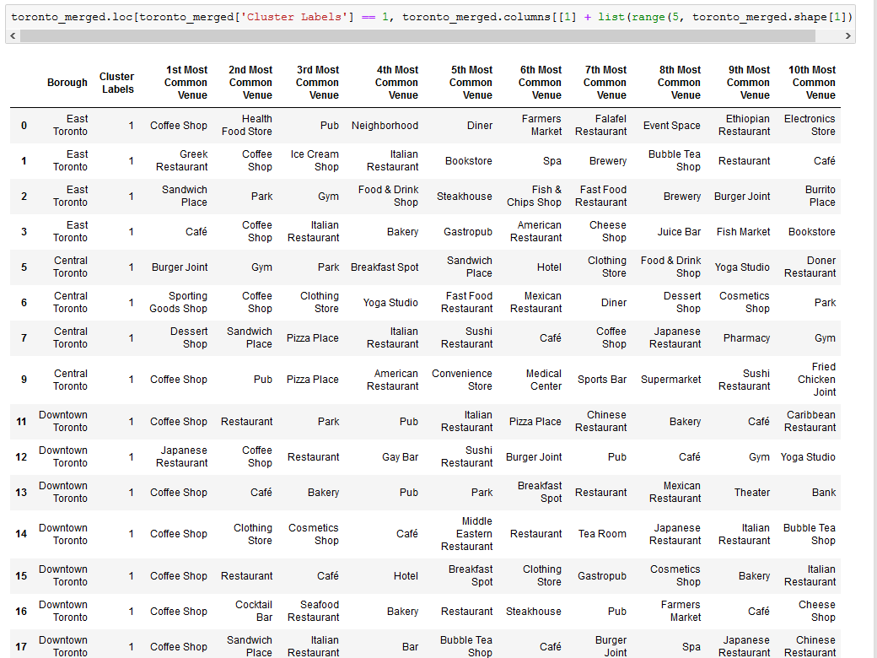

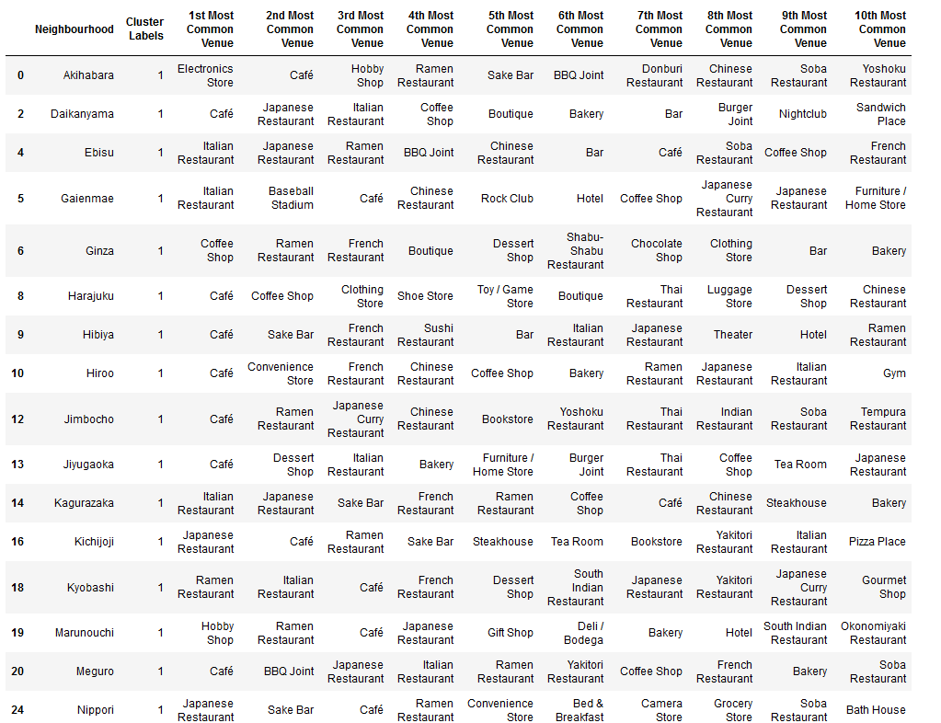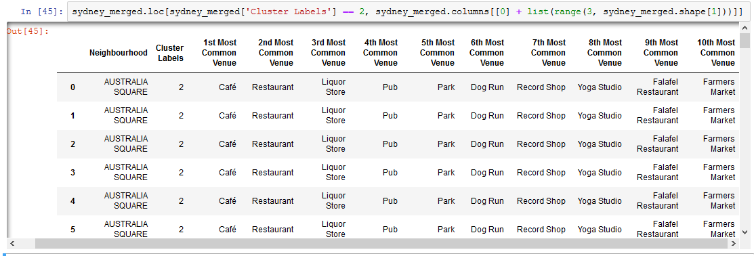

## **Result**

When we explorer the date and check the number of unique venues all these cities are the same.

Here is my observation of Tokyo’s data:

A few numbers of coffee shop, fast food and Pizza Place are in Tokyo, but Japanize traditional food restaurants are all over the place for example, Ramen, Yakitori and Sushi restaurants. There are Italian, French, Chinese and Indian restaurants in Tokyo.

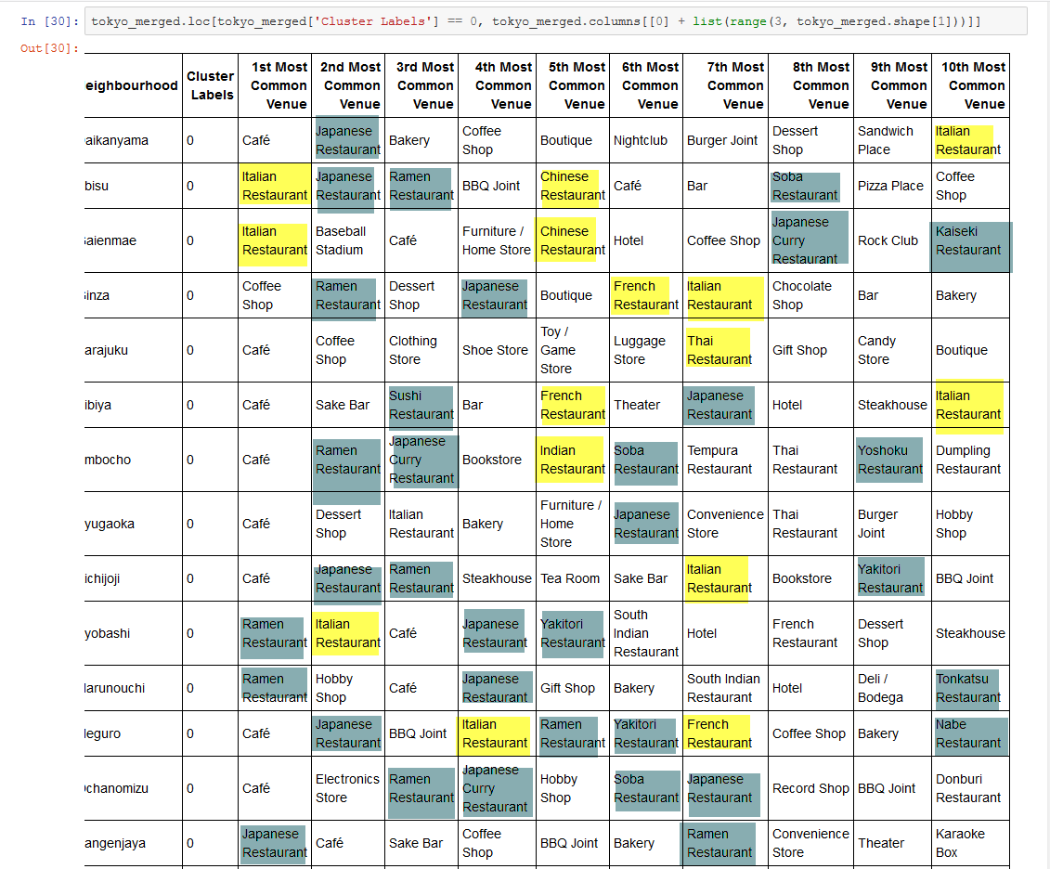

Here is Sydney’s data observation:

There are two major cluster exit in Sydney’s data frame cluster 0 and 2. In cluster 2 first most common venue is Café. Fast food, Pizza shop and all other different traditional restaurants can be found in this city. Sydney is a multicultural city and its venue proven this clime.

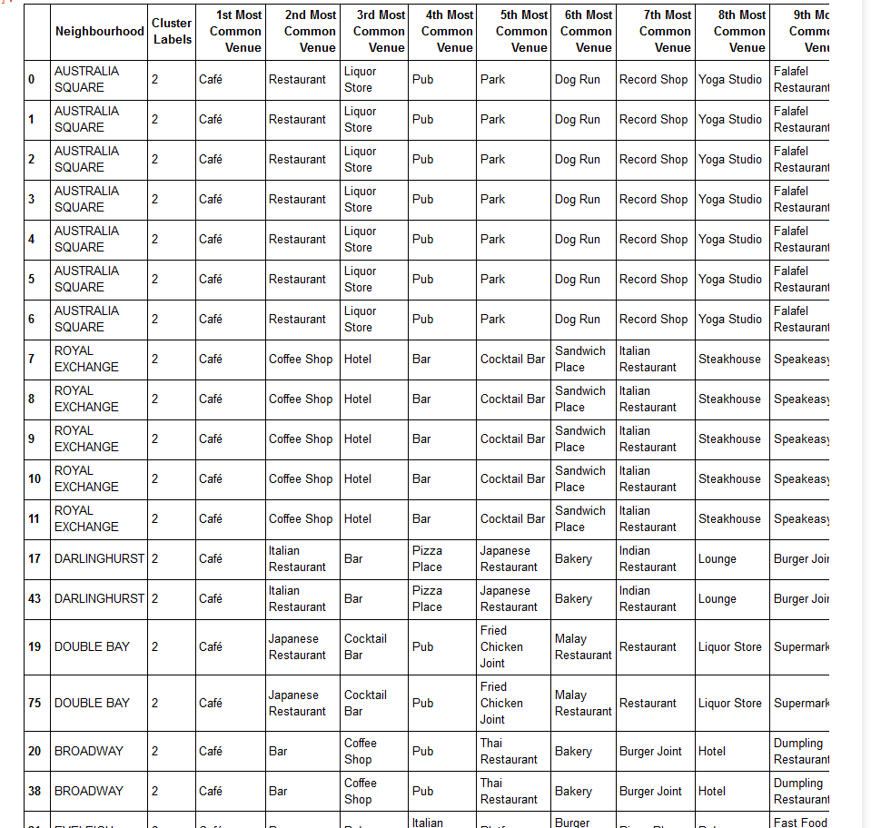

Toronto is another multicultural city as well if you look at the venues in this city it is clear and observable. You can find many different Restaurant in Toronto from East and West European, African, Medalist, south American and Asian. Also, Fast food, café shop and bar are in every neighborhood.

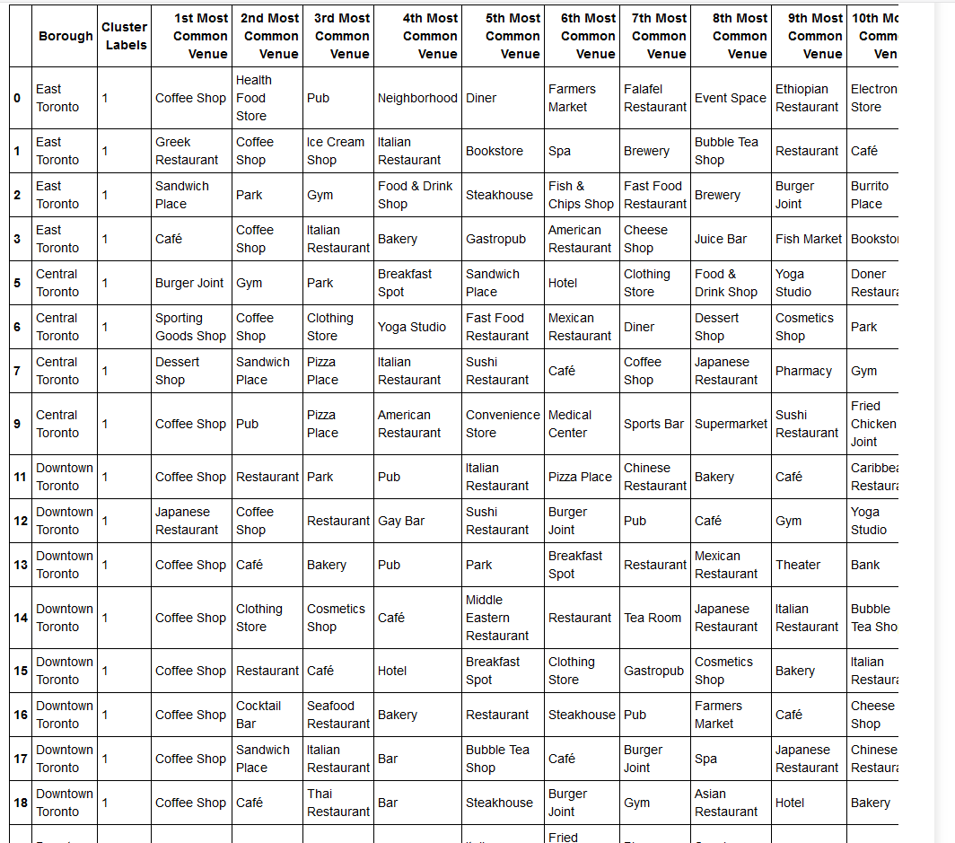

## **Discussion**

Sydney and Toronto have similar venues for example café shops many different traditional restaurants from all over the world. Every neighborhood has at list one pub or bar also, many neighborhoods has one Gym or Yoga Studio.

But the most interesting result for me the number of fast foods in Tokyo is so low. In Tokyo most of the neighborhoods have bar, club or BBQ Joint. Resident of Tokyo more like to keep their own traditional way of living.

I will recommend people who interested in traditional food and Japanese cultural activity, go to Tokyo. They always saying, if you like a testy Pizza best place is Italy also correct about best Sushi as well to go to Tokyo.

Also, if anyone like to see a diversity and many different culture and activity Sydney and Toronto are the best.

## **Conclusion**

Every city has its own attractive places that we can enjoy to see them. They have specific view that identify them from others and always something they have that is unique. Data science magnify things that you never expected. I had no information about Tokyo and daily life there but using Foursquare and data analysis you can have live activity of any place in earth.

At the end I tried to prepare a data that may be useful for anyone interested to have more dipper research about these cities. Therefor, I upload all the data into my GitHub to be used.

## **References**

Toronto – Wikipedia

Tokyo – Wikipedia

Sydney – Wikipedia

Foursquare API

Cora site for Australian data